Moldex3D Global Innovation Talent Award 2021
Essay Template
You can get extra credits by submitting your case study essay. Please write in English or Chinese using the template below, and send the essay to talentawards@moldex3d.com before July 15, 2022.

High Temperature Dilatometry Design and Application Considering Thermal History
Chen-Chieh Wang, Maw-Ling Wang and R-Y Chang
CoreTech System (Moldex3D) Co., Ltd., Chupei City, Hsinchu 30265, Taiwan

Abstract
A new dilatometry which up to 450℃ is designed and tested in this work. CAE software (Moldex3D) is used to aid the design of mold and the improvement of the control of temperature distribution. The thermal history and pressure effect on specific volume are studied for both semi-crystalline and amorphous polymer. Both materials show non-equilibrium behavior which dependent on pressure, and cooling rate.
Keywords: dilatometry, thermal history effect, non-equilibrium properties, crystalline kinetics

Introduction
Volume changes of material with time have a critical industrial relevance to product qualities for polymer processing. PVT equations of states have been used to predict the volume shrinkage of the product in most CAE software for decades. However, it is found that specific volume of polymer will shows history dependent behavior due to the relaxation process of molecular chains for amorphous material, instead of state function[1]. For semi-crystalline polymer the specific volumes are strongly dependent on the degree of crystallinity[2].
In this work, a new piston type dilatometry which can test up to 450℃ was designed and manufactured. By this instrument pressure and cooling rate effect on PVT diagram for both semi-crystalline and amorphous material studied.

The Development of PVT Instrument
The two main commercialized measurement techniques for PVT measurement are (1) confined fluid type and (2) piston type[3]. Although the piston type has more advantages, the leakage is his main disadvantage. To avoid the leakage a PTFE seal is used between each piston and the sample. Therefore, the working temperature is limited by the melting of PTFE (about 300℃). To overcome the limitation, a measuring system without seal is design and tested by using a high precision piston and chamber manufactured using a high modulus and low thermal expansion coefficient material. The size difference between piston and chamber is less than 5μm to make sure the piston can move smoothly without leakage. Moldex3D were used to study and improve the thermal efficient and temperature distribution of mold during heating and cooling procedure.

Testing of PVT diagram
A semi-crystalline polymer (PP Globalene 6331, LCY CHEMICAL) and an amorphous polymer (PS POLYREX PG-33, CHI-MEI) are tested by the developed PVT instrument. Isobaric cooling of various cooling rate (0.1~ 10℃/min) under pressure (30, 90, 150 MPa) are chosen to study the cooling rate effect.

Results and Discussion
The PVT diagram for PP is shown in Figure 1. The transition temperature is strong dependent on the cooling rate, because of the dependency of crystalline kinetics. The kinetic of crystallinity are measured by DSC and fitted by Nakamura model[4] as shown in Figure 2. It is worth to mention that specific volumes after solidification are different under various cooling rate despite the material should reach 100% relative crystalline which can be can be check by the latent heat (102.9±0.4 J/g ). That may results from the difference of crystalline morphology.
The drops of volume in PVT diagram are resulted from the occurrence of crystallinity. Therefore, the specific volume during transition region could be described by mixing rule as follows:
(1)
where α is the relative degree of crystallinity. V_{a} and V_{c} are the specific volume of amorphous phase and crystalline phase, respectively. The comparison between measured results and theoretical curve (Eq. 1) are shown in Figure 3. The model works well except the solid state which results from the difference of morphology.
PVT diagram of PS are shown in Figure 4. The glass transition points are affected by cooling rate. The shift in glass transition is about 3℃ per decade of cooling rate which agree with the results in the literature[5].

Conclusions
In this paper, we design a PVT instrument without PTFE seal which can extent the working temperature up to 450℃. A semi-crystalline and an amorphous polymer were tested by this instrument under various cooling rate. Both of the material show thermal and pressure historical dependent behavior which indicate the assumption of state function might be corrected.

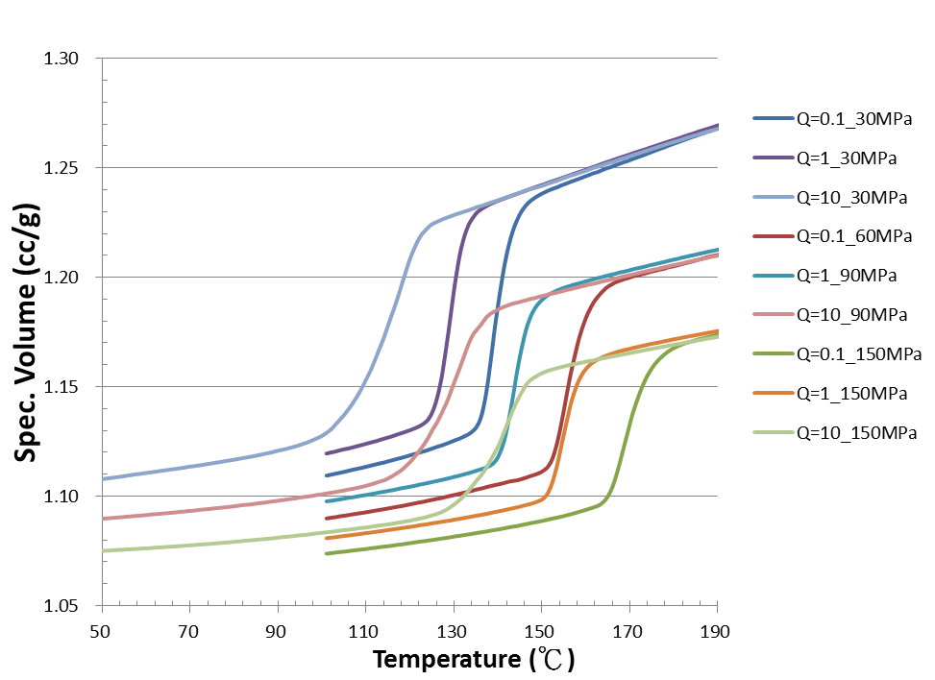
Figure 1. PVT diagram PP under various cooling rate

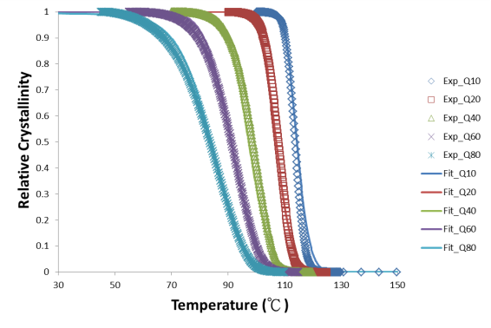
Figure 2. The relative crystallinity of PP DSC data (point) and the perdition of Nakamura model
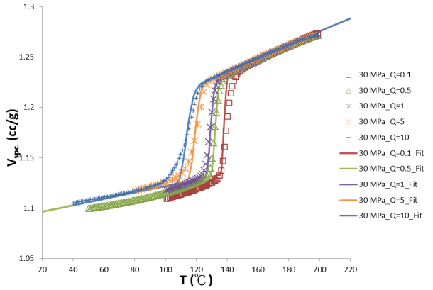
Figure 3. The comparison between measured point and theoretical curve (PP).
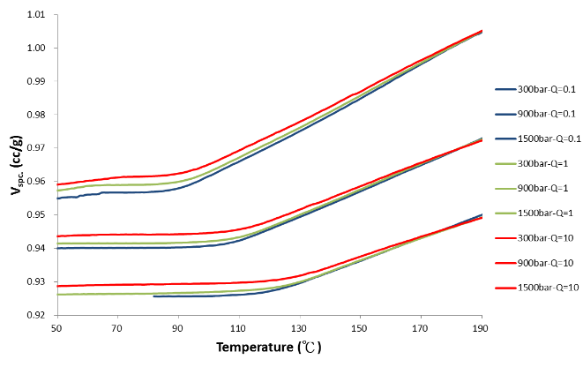
Figure 4. PVT diagram of PS under various cooling rate

References
1) J.D. Ferry, Viscoelastic Properties of Polymers. (Wiley, 1980).
2) H. Zuidema, G. W. M. Peters, and H. E. H. Meijer, Journal of Applied Polymer Science 82, 1170 (2001).
3) J. F. Luyé, G. Régnier, Ph Le Bot, D. Delaunay, and R. Fulchiron, Journal of Applied Polymer Science 79, 302 (2001).
4) Jianxin Guo and Kwabena A. Narh, Polymer Engineering & Science 41, 1996 (2001).
5) R. Y. Chang, C. H. Chen, and K. S. Su, Polymer Engineering & Science 36, 1789 (1996).

